

RAMON MAGSAYSAY MEMORIAL COLLEGES
Information Technology Education Program
1st SEMESTER: AY: 2025 - 2026

UNIVERSITY COURSE MANAGEMENT SYSTEM
DATABASE DESIGN ACTIVITY

Submitted by:
MARVIN M. MENESES
BSIT-3

Submitted to:
JIM JAMERO

August 28, 2026

- ERD WITH CARDINALITY
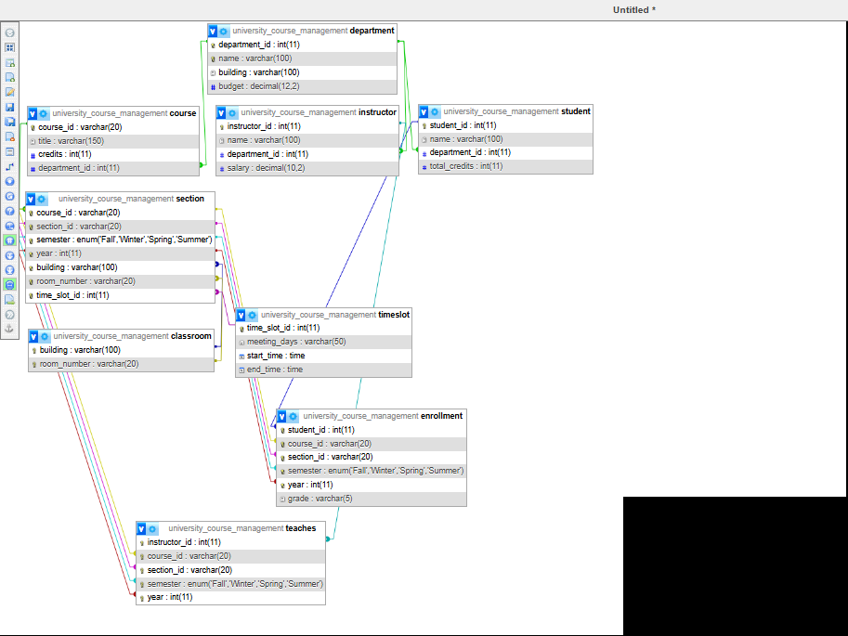
The ERD shows the relationships between the Department, Course, Instructor, Student, Section, Classroom, TimeSlot, Enrollment, and Teaches entities.

2. RELATIONAL SCHEMA

DEPARTMENT(
department_id PK,
name UNIQUE NOT NULL,
building,
budget NOT NULL CHECK (budget >= 100000)
)

COURSE(
course_id PK,
title NOT NULL,
credits NOT NULL,
department_id FK NOT NULL
)

INSTRUCTOR(
instructor_id PK,
name NOT NULL,
department_id FK NOT NULL,
salary NOT NULL CHECK (salary >= 4 AND salary <= 5000)
)

STUDENT(
student_id PK,
name NOT NULL,
department_id FK NOT NULL,
total_credits DEFAULT 0 CHECK (total_credits BETWEEN 0 AND 200)
)

CLASSROOM(
building PK,
room_number PK
)

TIME_SLOT(
time_slot_id PK,
meeting_days NOT NULL,
start_time NOT NULL,
end_time NOT NULL CHECK (end_time > start_time)
)

SECTION(
course_id PK, FK,
section_id PK,
semester PK CHECK (semester IN ('Fall','Winter','Spring','Summer')),
year PK,
building FK,
room_number FK,
time_slot_id FK,
UNIQUE (building, room_number, time_slot_id)
)

TEACHES(
instructor_id PK, FK,
course_id PK, FK,
section_id PK, FK,
semester PK,
year PK,
UNIQUE (course_id, section_id, semester, year)
)

ENROLLMENT(
student_id PK, FK,
course_id PK, FK,
section_id PK, FK,
semester PK, FK,
year PK, FK,
grade DEFAULT NULL

3. SQL CREATE TABLE STATEMENTS
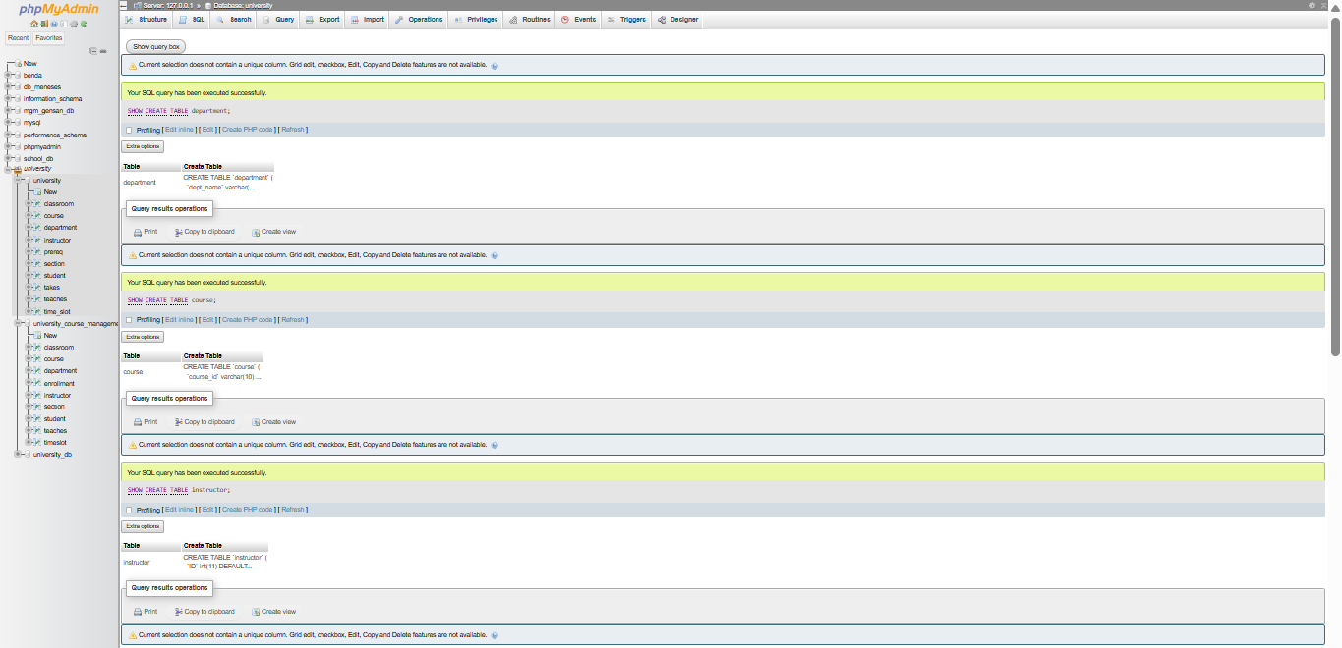
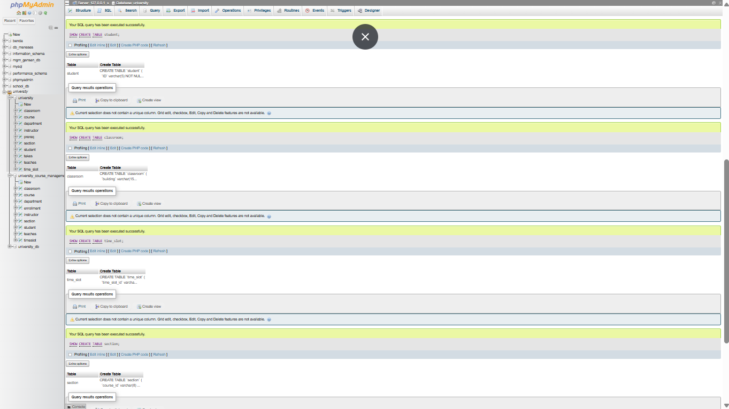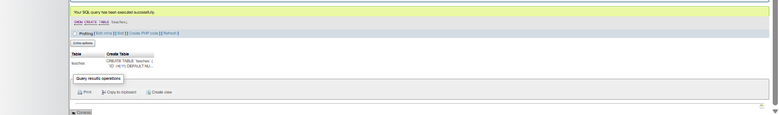

4. SAMPLE DATA
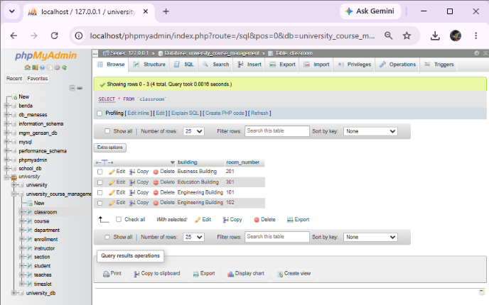 | 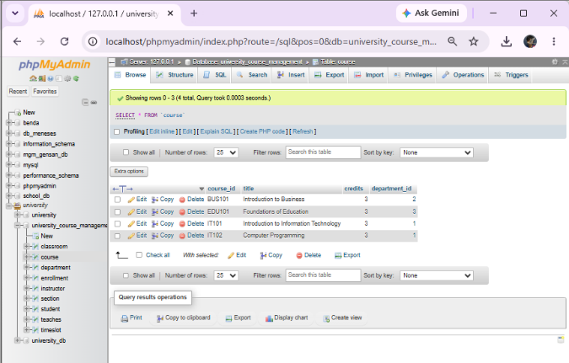
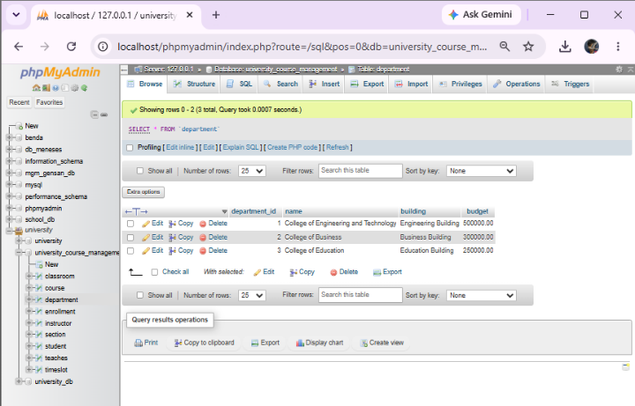 | 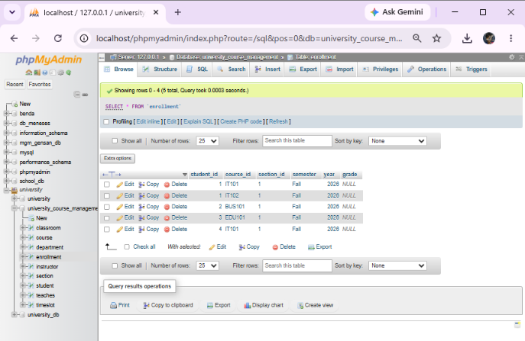
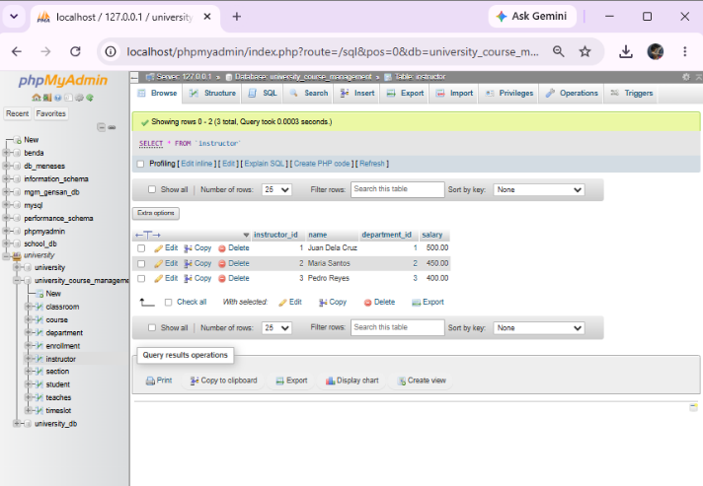 | 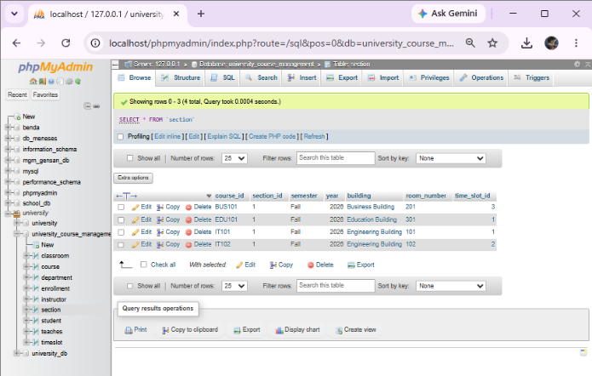
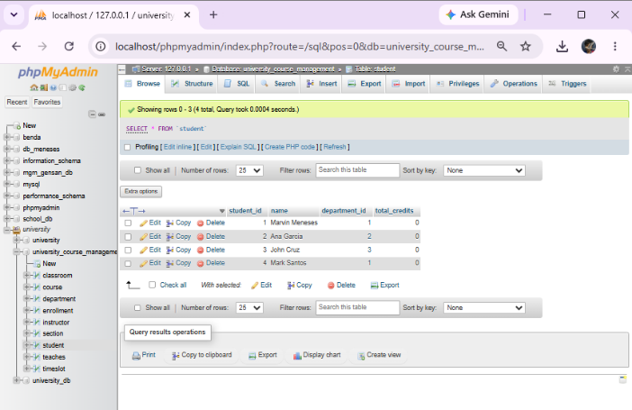 | 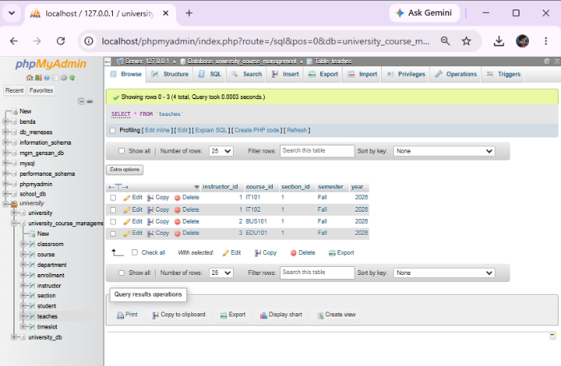
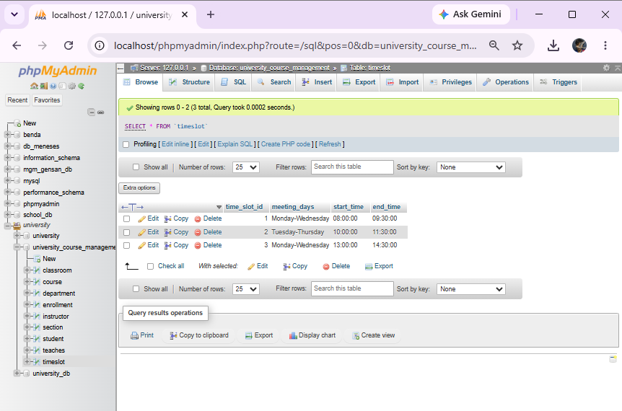

5. INTEGRITY CONSTRAINT TESTING

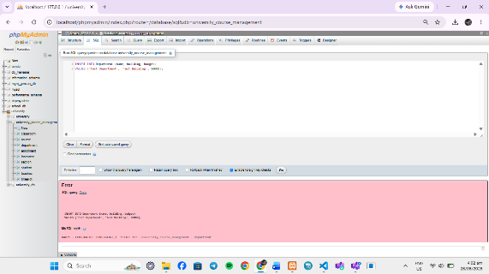 | 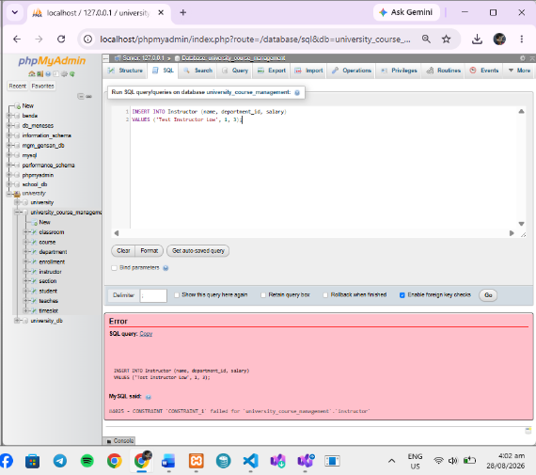
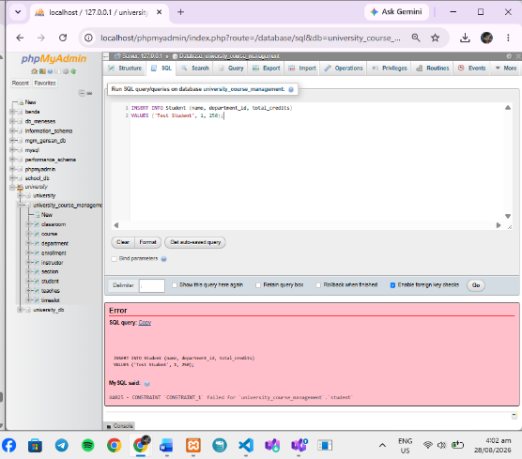 | 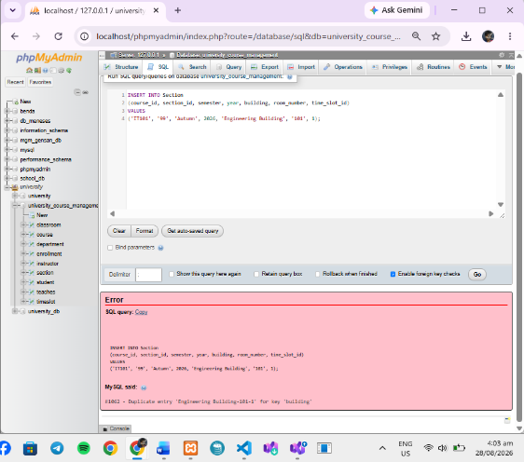

CONCLUSION

The University Course Management System database was successfully designed to organize and manage important university information, including departments, courses, instructors, students, sections, classrooms, schedules, and enrollments. The database structure helps ensure that information is stored in an organized and efficient way, making it easier to manage and retrieve data when needed.
Different database constraints, such as Primary Keys, Foreign Keys, NOT NULL, UNIQUE, DEFAULT, ENUM, and CHECK constraints, were applied to maintain data accuracy, consistency, and integrity. These constraints help prevent duplicate, incomplete, or invalid information from being entered into the system. The Entity Relationship Diagram (ERD) also clearly shows the relationships between the different entities and how they work together within the university system.
Overall, the ERD and SQL implementation demonstrate how a well-designed relational database can effectively manage university course information. The system provides a reliable foundation for handling student enrollments, instructor assignments, class schedules, and other academic records while reducing data redundancy and improving data organization. This database design can also be further developed in the future by adding features such as user accounts, grading, attendance tracking, and reporting.

